0
5000 ± Square Ft. Building 47 E. Madison Avenue

For Sale $1,100,000 Dumont, NJ 07628
Waldwick, NJ 07463

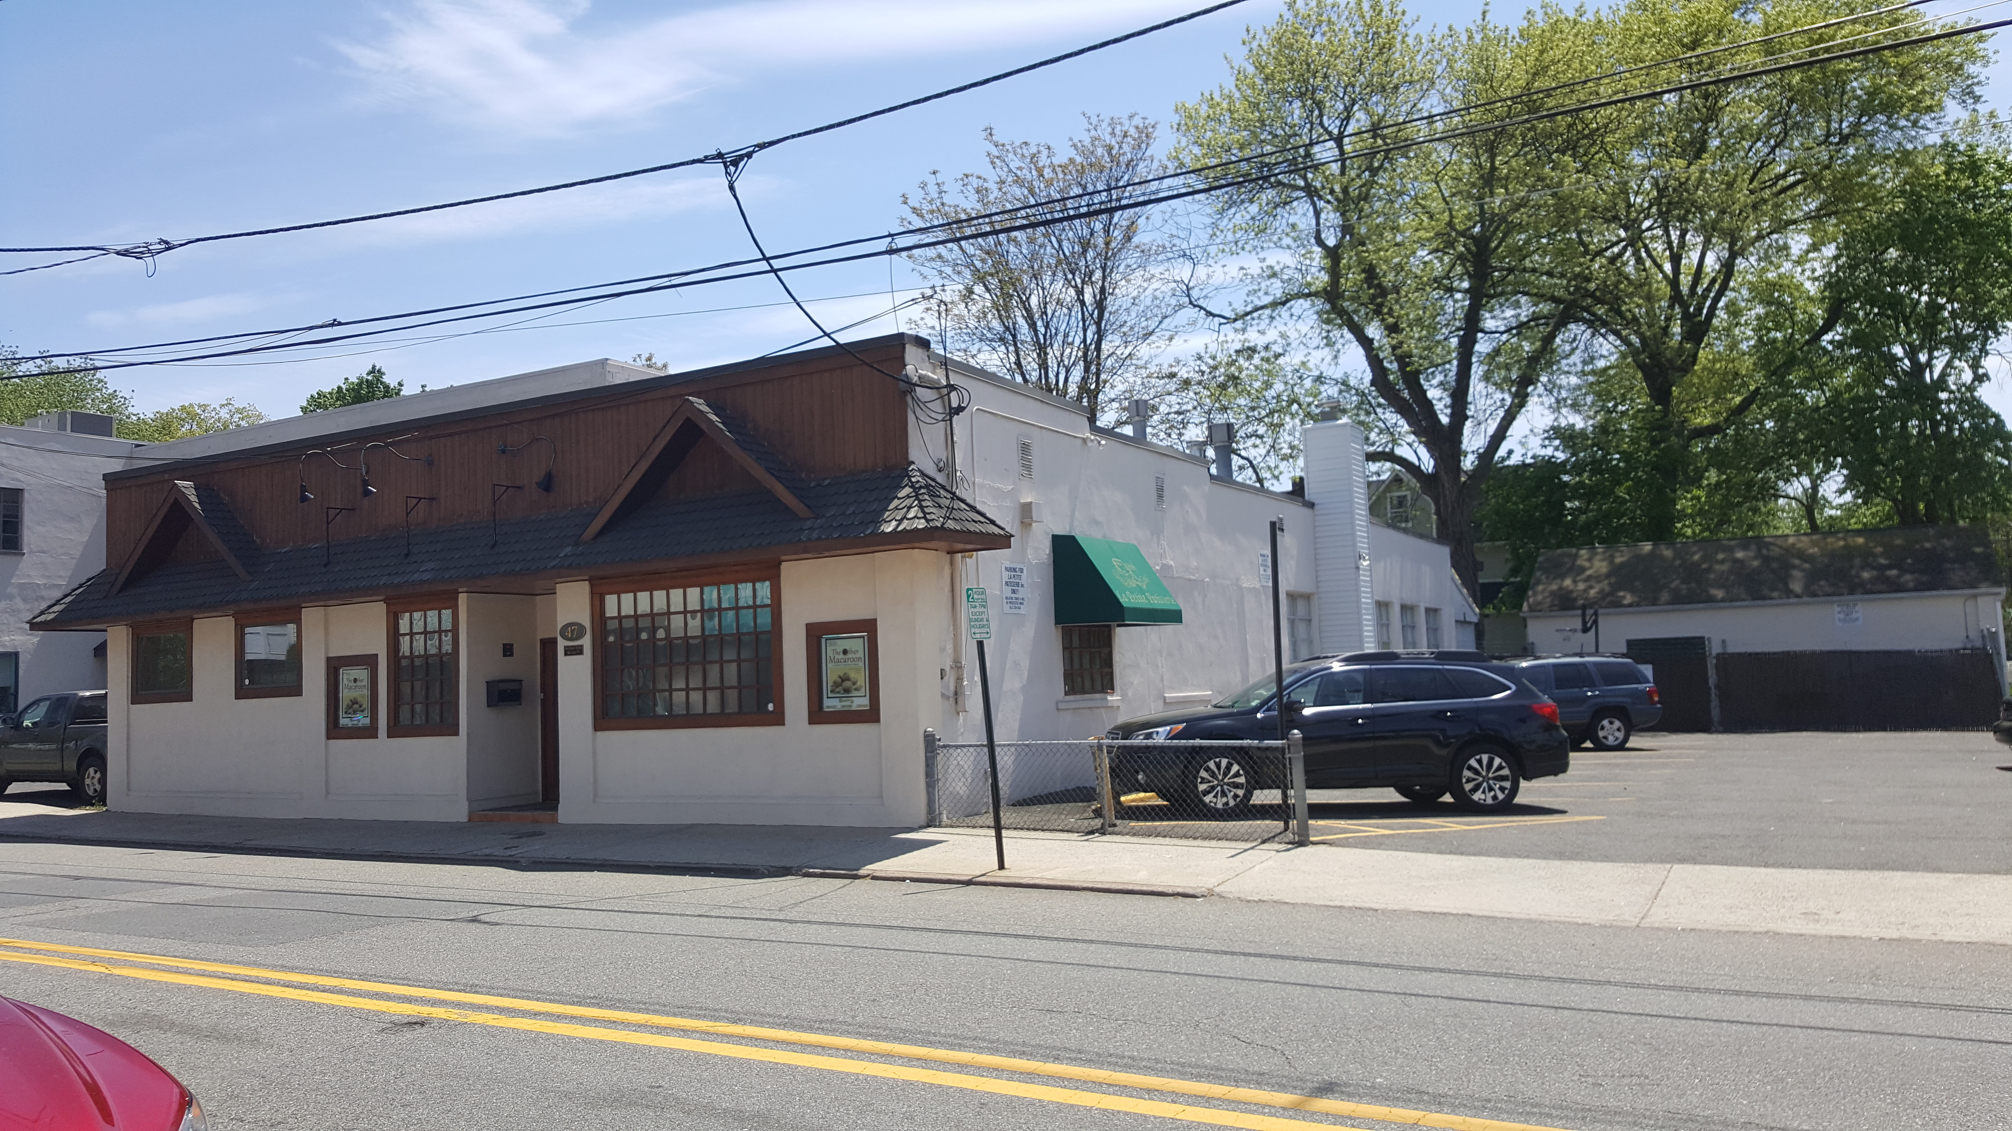
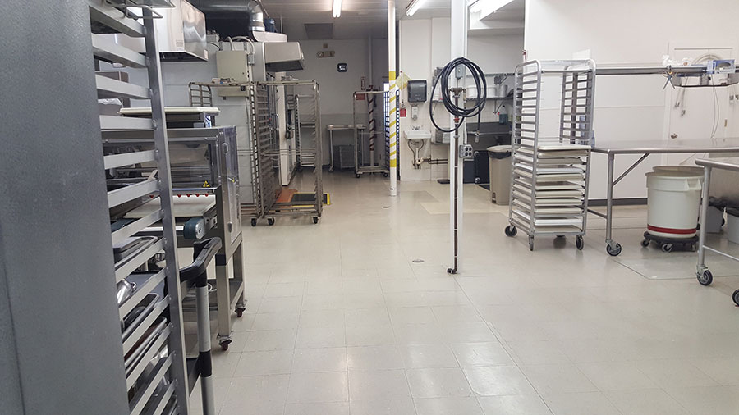

“Cookie Factory”
- Free Standing Building
- OUTSTANDING Curb Appeal with your own identity
- IDEAL wholesale/retail
BAKERY
- center of town location
- WALK-IN AND ROTATING OVENS
- 10’x20’ WALK-IN FREEZER BOX
(2) 10’X10’ refrigerator boxes
- 750 SQFT REAR BUILDING +
50’x100’ HOUSE LOT
- 14 car parking + bus stop



